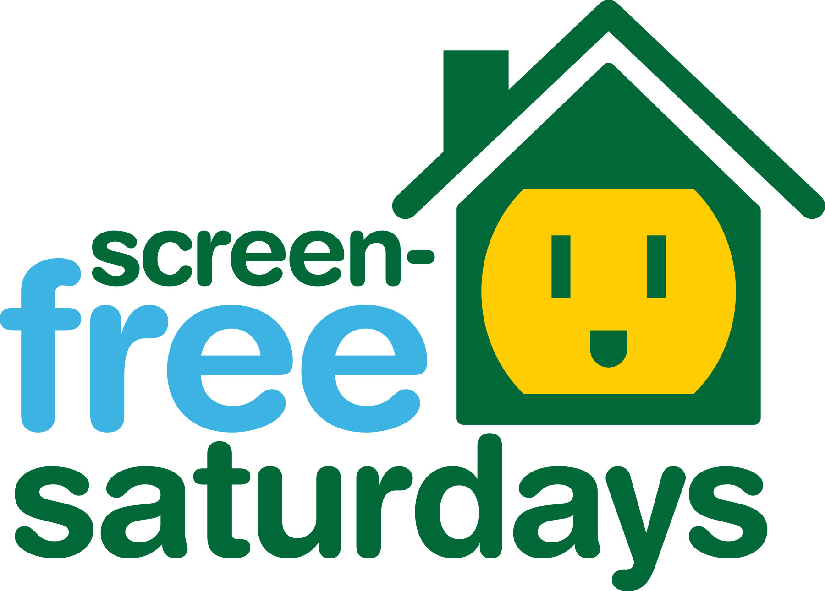
SAMPLE FAMILY LETTER
Dear Families:
This year, _____________[school] will be promoting Screen-Free Saturdays as a way to make sure students get a healthy dose of offline time-- especially while they learn remotely. Screen-Free Saturdays is an international program sponsored by Campaign for a Commercial-Free Childhood and celebrated by schools, families, and other civic and community groups throughout the year. Thousands of children and adults pledge to spend one day per week without entertainment devices on Screen-Free Saturdays. Instead of watching TV or playing video games, they tend to read, play, think, create, get physically active, and spend more time with friends and family.
Studies show that children who have less screen time are more likely to read well and to be physically fit. Turning off screens also allows for more family time. Before the pandemic, each week, American children spent more time in front of a screen than they do in school. Now, with school on the screen, this time on devices has increased exponentially. Screen-Free Saturdays can hold sacred the time off screens kids need and jump start them into more family fun and active play.
Many parents choose to join their children in foregoing screen-based entertainment for Screen-Free Saturdays. This kind of support is the best thing you can do to ensure that your child will have a successful and beneficial experience. Plus, it feels so good to take a break as adults, too.
Please let us know if you would like more information about the effects of excessive screen time for children and about Screen-Free Saturdays. You can also learn more by visiting www.screenfree.org/saturdays.
Sincerely,

